
“The Protocol for Human–AI Collaborative Intelligence”

Structured Reasoning • Data Ownership • AI Intellectual Property

ToolAi Light Paper

The Protocol for Collaborative Intelligence

Human–AI Collaboration • Data Ownership
Artificial Intelligence Intellectual Property
Version 1.0
March 2026

Powered by the HAICO Protocol: Human–AI Collaborative Optimization Architecture
Structured Reasoning • Intelligence Metrics • Data Ownership • AI Intellectual Property
www.ToolAi.com

Table of Contents

- Executive Summary
- Why ToolAi Wins
- How ToolAi Becomes a $1B Network
- The Problem
- The ToolAi Solution
- The HAICO Protocol
- ToolAi Mobile Application
- Data Ownership & Bread Points
- TAI+ Cryptocurrency
- Tokenomics
- DeFi Wallet
- AiiP Marketplace
- HAICO AiiPs
- The ToolAi Intelligence Flywheel
- Future Vision

ToolAi Light Paper v1

The Protocol for Human–AI Collaborative Intelligence

Enabling Structured Reasoning, Data Ownership, and Intelligence Markets

Version 1.0
ToolAi Labs

1. Executive Summary

Artificial intelligence is rapidly transforming how individuals and organizations solve problems. However, most AI systems today operate through simple prompt-response interactions that often replace human reasoning rather than amplifying it.

At the same time, modern AI platforms rely heavily on data generated by users, yet those users rarely retain ownership of their contributions or participate in the economic value created by the systems they help improve.

ToolAi introduces a new paradigm for human–AI collaboration.

ToolAi is a collaborative intelligence platform powered by the HAICO protocol (Human–AI Collaborative Optimization), a structured framework that enables humans and artificial intelligence systems to reason together.

The ToolAi ecosystem enables:

• structured human–AI reasoning workflows
• improved AI reliability through validation systems
• collaborative intelligence measurement
• user-controlled data ownership
• decentralized economic participation through tokens
• open markets for AI intellectual property

Through the ToolAi mobile application, users interact with AI systems using structured reasoning workflows that produce reasoning trace datasets capable of improving future AI models.

Users can optionally share different types of data with the ecosystem and earn rewards through Bread Points and TAI+ tokens.

The platform also introduces the AiiP Marketplace, where users can mint and trade Artificial Intelligence Intellectual Property assets representing AI tools, reasoning systems, and collaborative intelligence models.

Together, ToolAi and the HAICO protocol form the foundation for a new infrastructure layer for the AI economy: collaborative intelligence networks.

Why ToolAi Wins


The Next Infrastructure Layer for Artificial Intelligence

Artificial intelligence is transforming every industry, yet most AI systems today are built on a flawed interaction model.

Traditional AI platforms operate through simple prompt-response interfaces that prioritize automation over collaboration. While powerful, this approach limits the reliability of AI outputs, fails to measure collaborative intelligence, and extracts data from users without providing ownership or economic participation.

ToolAi introduces a new architecture for human–AI interaction.

By combining structured reasoning protocols, user-controlled data ownership, decentralized economic incentives, and open markets for AI intellectual property, ToolAi establishes the foundation for collaborative intelligence networks.

The AI Platform Evolution

Search Engines
(Google)

↓

Social Networks
(Facebook, X)

↓

Mobile App Platforms
(Apple, Android)

↓

AI Assistants
(OpenAI, Anthropic)

↓

Collaborative Intelligence Networks
(ToolAi + HAICO)

ToolAi represents the next stage of AI platform evolution.

Why ToolAi Is Different

Category | Traditional AI Platforms | ToolAi
AI Interaction | Prompt Response | Structured reasoning collaboration
Human Role | Passive user | Active reasoning partner
AI Reliability | Often hallucinated | Validation architecture
Data Ownership | Platform-owned | User-owned
Economic Participation | None | Data rewards
AI Intellectual Property | Closed models | AiiP marketplace
AI Learning | Static datasets | Continuous co-evolution
Platform Architecture | Centralized | Collaborative intelligence protocol

ToolAi vs Existing AI Platforms

Platform | Focus | Limitation
OpenAI | AI models | Limited human reasoning integration
Anthropic | AI safety | Closed model architecture
Google | AI services | Data extraction without ownership
Crypto AI projects | decentralized compute | lack reasoning architecture
ToolAi | collaborative intelligence protocol | open ecosystem

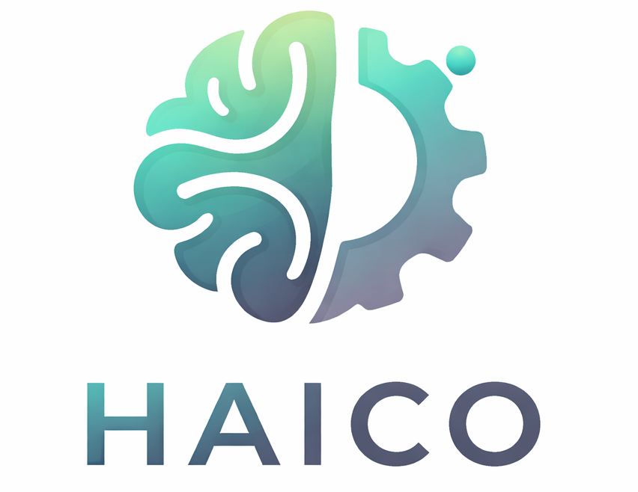
ToolAi’s Strategic Advantages

1. The HAICO Protocol

ToolAi introduces the Human–AI Collaborative Optimization (HAICO) protocol, which structures reasoning interaction between humans and artificial intelligence systems.

This protocol:

• reduces hallucinated outputs
• improves reasoning transparency
• measures collaborative intelligence
• enables continuous co-evolution learning

2. Data Ownership Economy

Users control their data through the ToolAi mobile application.

Participants may share different categories of data including:

• reasoning trace data
• web interaction data
• device signals
• application workflow data
• behavioral reasoning patterns

Users earn Bread Points for contributing data to the collaborative intelligence network.

3. Tokenized Intelligence Economy

The ToolAi ecosystem uses TAI+ cryptocurrency to facilitate transactions.

TAI+ powers:

• ecosystem payments
• AiiP minting fees
• AI service transactions
• data licensing

Every transaction includes a 2% ecosystem fee that contributes to the community reward pool distributed to data contributors.

4. AiiP Marketplace

ToolAi introduces the AiiP Marketplace, where users can mint Artificial Intelligence Intellectual Property assets.

AiiPs represent:

• AI tools
• reasoning systems
• collaborative intelligence models

This allows developers, researchers, and creators to own and monetize AI systems they build within the ToolAi ecosystem.

Network Effects

ToolAi benefits from powerful network effects created by collaborative intelligence.

More Users
↓
More Reasoning Data
↓
Better AI Systems
↓
More Valuable AiiPs
↓
More Marketplace Activity
↓
More Users

This creates a self-reinforcing intelligence network.

Why Now

Several technological shifts make ToolAi possible today:

AI adoption is accelerating

Artificial intelligence is becoming a core tool for individuals and organizations worldwide.

Data ownership is becoming critical

Users increasingly demand control over how their data is used.

Decentralized finance enables new economic models

Blockchain infrastructure allows users to participate directly in digital economies.

Collaborative intelligence is the next frontier

The future of AI is not autonomous systems replacing humans, but intelligence networks where humans and machines collaborate.

ToolAi Competitive Moat
Why ToolAi Cannot Be Easily Replicated

As artificial intelligence continues to evolve, the primary concern for investors is not just innovation, but defensibility.

Many AI products can be replicated.
Protocols and ecosystems cannot.

ToolAi’s competitive advantage is built on a multi-layered moat, combining protocol architecture, data network effects, economic incentives, and intellectual property.

1. Protocol-Level Advantage (HAICO)

ToolAi is not just an application — it is built on the HAICO protocol, which structures how humans and artificial intelligence systems interact.

Unlike traditional AI systems that rely on simple prompt-response interactions, HAICO introduces:

• structured reasoning workflows
• validation mechanisms
• collaborative intelligence metrics
• reasoning trace infrastructure
• human–AI co-evolution learning

This creates a new category of AI interaction, not just an improvement of existing ones.

🔹 Competitors would need to rebuild interaction architecture from the ground up, not just copy features.

2. Proprietary Reasoning Trace Data Network

ToolAi captures a unique form of data:

reasoning trace data

This includes:

• human reasoning steps
• hypothesis exploration
• validation interactions
• collaborative intelligence signals

This dataset is fundamentally different from traditional AI training data.

It represents how humans think, not just what they say.

Over time, this creates a proprietary intelligence dataset that improves:

• AI reasoning quality
• hallucination reduction
• collaborative intelligence performance

🔹 This becomes a data moat that compounds over time

3. Network Effects Through Collaborative Intelligence

ToolAi is designed as a network-driven system, not a standalone product.

The platform improves as more users participate:

More Users
↓
More Reasoning Data
↓
Better AI Systems
↓
More Valuable AiiPs
↓
More Marketplace Activity
↓
More Users

This creates a self-reinforcing flywheel.

🔹 Competitors cannot replicate this without:

users
data
ecosystem participation

4. Economic Moat (TAI+ & Bread System)

ToolAi introduces a native economic layer that aligns incentives across the ecosystem.

Key components:

• TAI+ token (multi-chain settlement layer)
• Bread Points (data contribution rewards)
• 2% transaction fee redistributed to contributors

This creates:

• user retention through rewards
• continuous data contribution
• economic participation in AI growth

🔹 Unlike traditional AI platforms, users are not just consumers — they are stakeholders

5. AiiP Marketplace (AI Ownership Layer)

The AiiP Marketplace introduces ownership of AI systems.

Users can:

• mint AI tools
• preserve intellectual property
• sell or license AI systems

This creates:

• developer incentives
• creator economy
• AI asset liquidity

🔹 Competitors without ownership layers remain closed ecosystems

6. Multi-Layer Patent Strategy (Critical)

ToolAi is supported by a portfolio of patents covering the full architecture:

• human–AI interaction protocols
• reasoning trace infrastructure
• collaborative intelligence metrics
• co-evolution learning systems
• AI reasoning marketplaces

These patents are structured to:

• cover individual components
• cover system interactions
• cover full architecture implementations

🔹 This creates both:

offensive protection (licensing opportunities)
defensive protection (blocking competitors)

7. Integration Across the Full Stack

Most AI companies operate in one layer:
Layer | Example Companies
Models | OpenAI
Infrastructure | AWS
Apps | SaaS Tools
Crypto | Token Projects

ToolAi integrates all layers:

• protocol (HAICO)
• application (mobile app)
• data layer (reasoning traces)
• economic layer (TAI+)
• marketplace (AiiPs)

🔹 This creates a full-stack moat

8. Switching Costs

As users engage with ToolAi, they build:

• reasoning performance history
• collaborative intelligence scores
• AiiP assets
• data contribution profiles

These elements are:

• persistent
• valuable
• difficult to replicate elsewhere

🔹 This creates high switching costs

9. First-Mover Advantage in a New Category

ToolAi is not competing in existing categories.

It is defining a new one:

Collaborative Intelligence Networks

This includes:

• structured human–AI reasoning
• intelligence measurement
• co-evolution learning
• AI intellectual property markets

🔹 First movers in protocol layers often become dominant standards

10. Why Big Tech Cannot Easily Copy This

Large AI companies face structural limitations:

They rely on centralized data ownership

ToolAi enables user-owned data

They optimize for speed and scale

ToolAi optimizes for reasoning quality and collaboration

They operate closed ecosystems

ToolAi enables open marketplaces and tokenized ownership

They cannot easily introduce token economies

ToolAi is built around one from the start

🔹 Copying ToolAi would require changing their entire business model

Summary

ToolAi’s competitive moat is not based on a single advantage.

It is built on:

• protocol innovation
• proprietary data
• network effects
• economic incentives
• intellectual property
• full-stack integration

Together, these create a system that becomes more powerful, more valuable, and more difficult to replicate over time.

How ToolAi Becomes a $1B+ Network

The Path to Scale, Adoption, and Market Dominance

ToolAi is designed not as a single product, but as a scalable intelligence network with multiple compounding growth drivers.

The combination of protocol infrastructure, data network effects, economic incentives, and AI intellectual property markets creates a system capable of reaching significant scale.

1. The Foundation: Protocol + Product

ToolAi begins with:

• a working mobile application
• the HAICO collaborative intelligence protocol
• integrated AI interaction workflows
• a built-in DeFi wallet and token system

This provides immediate utility:

• users can interact with AI
• users can share data
• users can earn rewards
• users can create AI tools

🔹 This is critical — you are not starting from zero.

2. Phase 1 — User Adoption (0 → 100K Users)

Initial growth is driven by:

• free premium AI access
• rewards for data contribution
• viral social campaigns (bounty programs, referrals)
• crypto community onboarding

Key value proposition:

🔹 “Use AI for free + earn from your data”

At this stage:

• data begins accumulating
• reasoning trace datasets begin forming
• early AiiPs begin appearing

3. Phase 2 — Data Network Effects (100K → 1M Users)

As usage increases:

• reasoning trace data grows exponentially
• AI performance improves
• collaborative intelligence metrics become meaningful

This leads to:

• better outputs
• reduced hallucinations
• improved user trust

🔹 The platform becomes noticeably better than alternatives

4. Phase 3 — Marketplace Expansion (1M → 5M Users)

The AiiP Marketplace becomes a major growth driver.

Users begin:

• creating AI tools
• selling reasoning systems
• licensing AI intellectual property

This creates:

• a creator economy
• developer participation
• marketplace liquidity

🔹 ToolAi transitions from product → platform economy

5. Phase 4 — Economic Flywheel Activation

At scale:

• TAI+ transaction volume increases
• the 2% ecosystem fee grows
• the reward pool expands

This leads to:

• higher user earnings
• more data contribution
• stronger retention

🔹 The system becomes self-reinforcing

6. Phase 5 — Enterprise & Institutional Adoption

Once the system proves:

• improved reasoning reliability
• measurable intelligence performance
• structured decision-making

ToolAi can expand into:

• enterprise decision-support systems
• research institutions
• government and defense applications
• education systems

These use cases unlock:

• high-value contracts
• large-scale deployments
• recurring revenue streams

7. Phase 6 — Protocol Adoption (The Biggest Unlock)

The most important growth phase:

🔹 HAICO becomes a standard

Other platforms begin integrating:

• structured reasoning workflows
• validation protocols
• collaborative intelligence metrics

This creates:

• licensing opportunities
• protocol-level integrations
• cross-platform interoperability

🔹 ToolAi becomes infrastructure

8. Revenue Streams

ToolAi generates revenue through multiple channels:

Transaction Fees

2% fee on TAI+ transactions

AiiP Marketplace Fees

Minting, listing, and transaction fees

Data Licensing

Aggregated reasoning datasets licensed to enterprises

Premium AI Services

Advanced tools and enterprise features

Protocol Licensing (Future)

HAICO integration by third-party platforms

9. Why This Reaches $1B+ Valuation

ToolAi combines characteristics of multiple high-value categories:
Category | Comparable
AI Platforms | OpenAI
Marketplaces | App Store
Data Networks | Palantir
Crypto Ecosystems | Ethereum

Instead of being one of these, ToolAi is:

🔹 all of them combined

Valuation Drivers

1. Network Effects

More users → more data → better AI → more users

2. Data Moat

Unique reasoning trace datasets

3. Token Economy

TAI+ creates measurable ecosystem value

4. Marketplace Liquidity

AiiP trading creates economic activity

5. Protocol Layer Potential

HAICO as industry standard

10. The End State

At scale, ToolAi becomes:

• a global collaborative intelligence network
• a marketplace for AI intellectual property
• a data infrastructure layer for reasoning systems
• a protocol standard for human–AI interaction

This creates a system where:

🔹 humans and AI co-evolve
🔹 intelligence becomes measurable
🔹 data ownership is preserved
🔹 economic value is shared

The Big Picture

ToolAi is not just building:

• an app
• a token
• an AI tool

It is building:

🔹 the infrastructure for collaborative intelligence

The Vision

ToolAi aims to become the foundational infrastructure for collaborative intelligence networks.

By combining structured reasoning protocols, decentralized economic incentives, and open AI intellectual property markets, ToolAi enables humans and artificial intelligence systems to co-evolve.

The result is a new kind of intelligence infrastructure:

Human + AI working together to produce reliable reasoning, measurable knowledge, and shared economic value.

2. The Problem

AI Systems Replace Human Reasoning

Most artificial intelligence systems today operate through a simple interaction model:

Human Prompt → AI Response

While powerful, this model often encourages passive consumption of AI-generated answers rather than active reasoning engagement.

This creates several challenges:

• hallucinated outputs
• reduced reasoning transparency
• lack of validation mechanisms
• shallow human cognitive engagement
• limited accountability for AI-generated decisions

AI systems should not replace human reasoning — they should amplify it.

Human Data Is Extracted Without Ownership

Modern AI models are trained using enormous datasets derived from human-generated data.

These datasets include:

• reasoning patterns
• problem-solving strategies
• domain expertise
• behavioral interaction signals

However, individuals rarely receive ownership rights or economic participation for the data they generate.

The result is a growing imbalance between AI platforms and the people whose knowledge powers them.

Collaborative Intelligence Is Not Measured

Traditional AI systems evaluate performance using metrics such as:

• benchmark accuracy
• latency
• model size

These metrics fail to measure something critical:

How intelligence improves when humans and AI collaborate.

Without such measurement systems, it is impossible to optimize human–AI collaboration.

3. The ToolAi Solution

ToolAi introduces a collaborative intelligence platform designed to improve how humans and AI systems work together.

The platform is built on four core principles:

Structured reasoning interaction
Collaborative intelligence measurement
Data ownership and participation
Open AI intellectual property markets

These principles are implemented through the HAICO Protocol.

4. The HAICO Protocol

The Human–AI Collaborative Optimization (HAICO) protocol governs structured interaction between humans and artificial intelligence systems.

Unlike traditional AI interaction models, HAICO introduces a structured reasoning workflow.

Problem Input
↓
Structured Human Reasoning
↓
AI Reasoning Generation
↓
Reasoning Validation
↓
Collaborative Intelligence Metrics
↓
Reasoning Trace Capture
↓
Human–AI Co-Evolution Learning
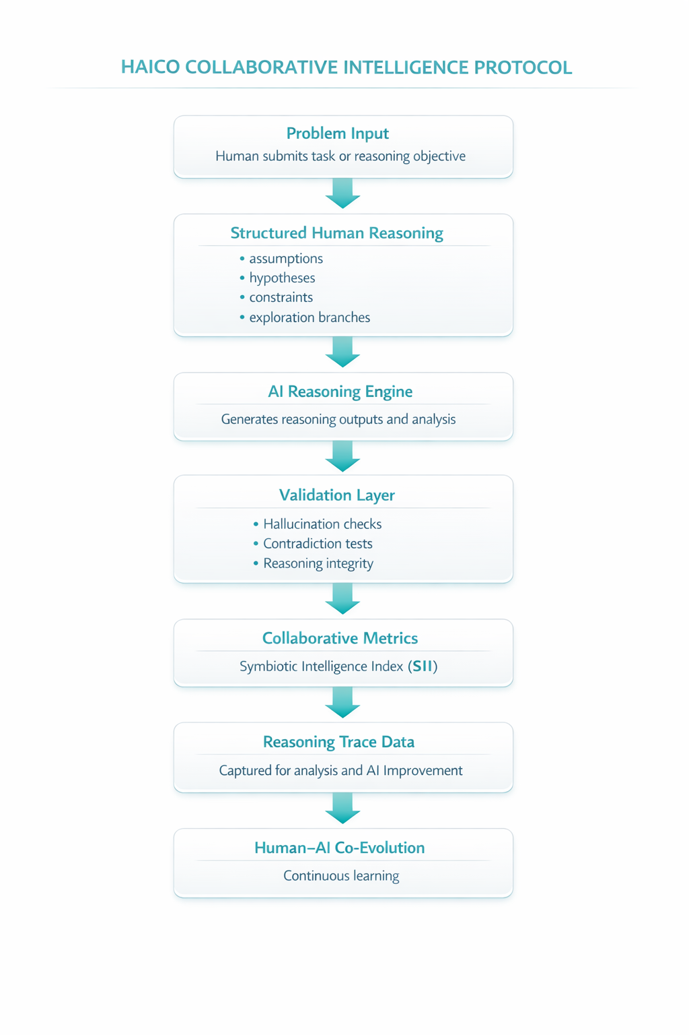
This architecture enables:

• improved reasoning reliability
• reduced hallucinated outputs
• measurable collaborative intelligence
• continuous improvement of both human and AI reasoning

5. ToolAi Mobile Application

The ToolAi mobile application serves as the primary interface for interacting with the HAICO collaborative intelligence system.

Users can:

• collaborate with AI systems through structured reasoning workflows
• control data sharing through privacy toggles
• track collaborative intelligence metrics
• earn ecosystem rewards
• interact with the AiiP marketplace

The application gives users control over how their data contributes to the broader intelligence network.

6. Data Ownership and Participation

ToolAi is designed around user-controlled data ownership.

Users maintain control over whether their data is shared with the collaborative intelligence ecosystem.

Through the ToolAi mobile application, users can selectively share multiple categories of data.

Data Types That Earn Bread Points

Users may earn Bread Points by sharing different types of data, including:

Reasoning Trace Data

Structured reasoning interactions generated during collaboration with AI systems.

Examples include:

• reasoning steps
• hypothesis exploration
• validation interactions
• collaborative reasoning improvements

Web Interaction Data

Optional anonymized web interaction signals that help AI systems understand research and knowledge discovery patterns.

Device Data Signals

Data related to device interaction and performance environments that help optimize AI system performance.

Application Interaction Data

Workflow patterns generated when users interact with productivity applications.

Behavioral Interaction Data

Signals related to decision-making processes and reasoning strategies.



7. Bread Points

Bread Points represent contributions to the collaborative intelligence ecosystem.

Users earn Bread Points when they share data through the ToolAi platform.

Bread Points are calculated based on:

• number of data points shared
• participation in collaborative reasoning workflows
• contribution to reasoning trace datasets



8. TAI+ Cryptocurrency

TAI+ is the native settlement token of the ToolAi ecosystem.

It is designed to support secure transactions both within and outside the platform.

TAI+ operates across multiple blockchain networks including:

• BNB Chain
• Ethereum
• Solana

9. Community Reward Pool

Every TAI+ transaction includes a 2% ecosystem fee.

This fee contributes to a community reward pool distributed to users who contribute data to the collaborative intelligence ecosystem.

Distribution is proportional to the number of data points contributed.

10. DeFi Wallet Integration

The ToolAi mobile application includes a built-in DeFi wallet that allows users to:

• store TAI+ tokens
• receive ecosystem rewards
• perform marketplace transactions
• convert fiat currencies to TAI+

The wallet supports both on-ramp and off-ramp services.

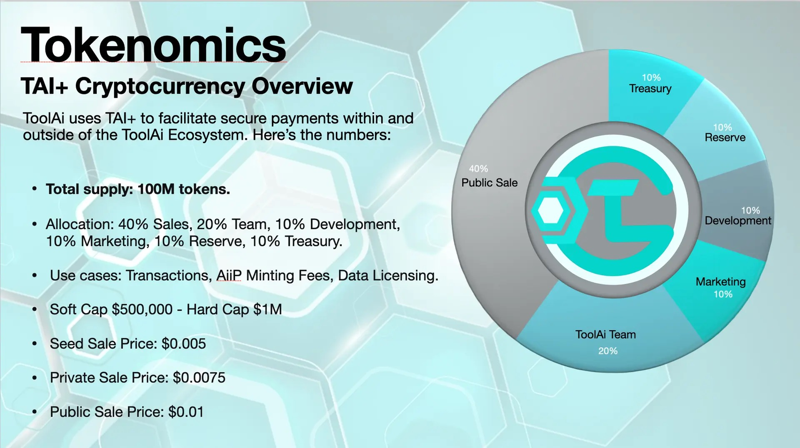
11. TAI+ Tokenomics

Total Supply: 100,000,000 TAI+ Tokens
Allocation
Category | Allocation
Sales | 40%
Team | 20%
Development | 10%
Marketing | 10%
Reserve | 10%
Treasury | 10%

Token Sale Pricing
Seed Sale: $0.005
Private Sale: $0.0075
Public Sale: $0.01

Soft Cap: $500,000
Hard Cap: $1,000,000

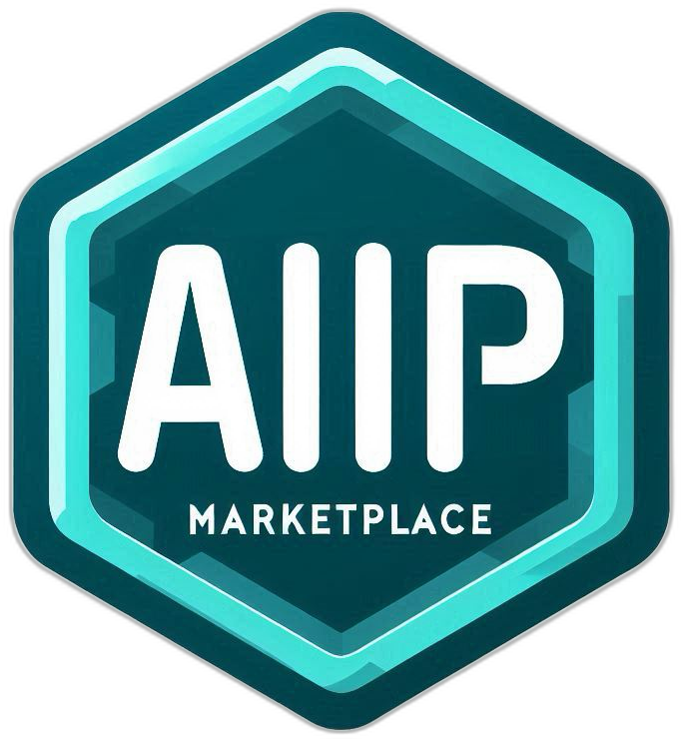
Use Cases

• ecosystem transactions
• AiiP minting fees
• data licensing
• collaborative intelligence services

12. The AiiP Marketplace

The ToolAi ecosystem includes the AiiP Marketplace, where users can mint and trade Artificial Intelligence Intellectual Property assets.

AiiPs may represent:

• AI reasoning systems
• collaborative intelligence tools
• optimized reasoning workflows

Minting an AiiP preserves:

• intellectual property ownership
• attribution of reasoning contributions
• traceability of collaborative intelligence generation

13. HAICO AiiPs


HAICO AiiPs are AI reasoning systems optimized for collaborative intelligence.

These systems are designed to:

• amplify human cognition
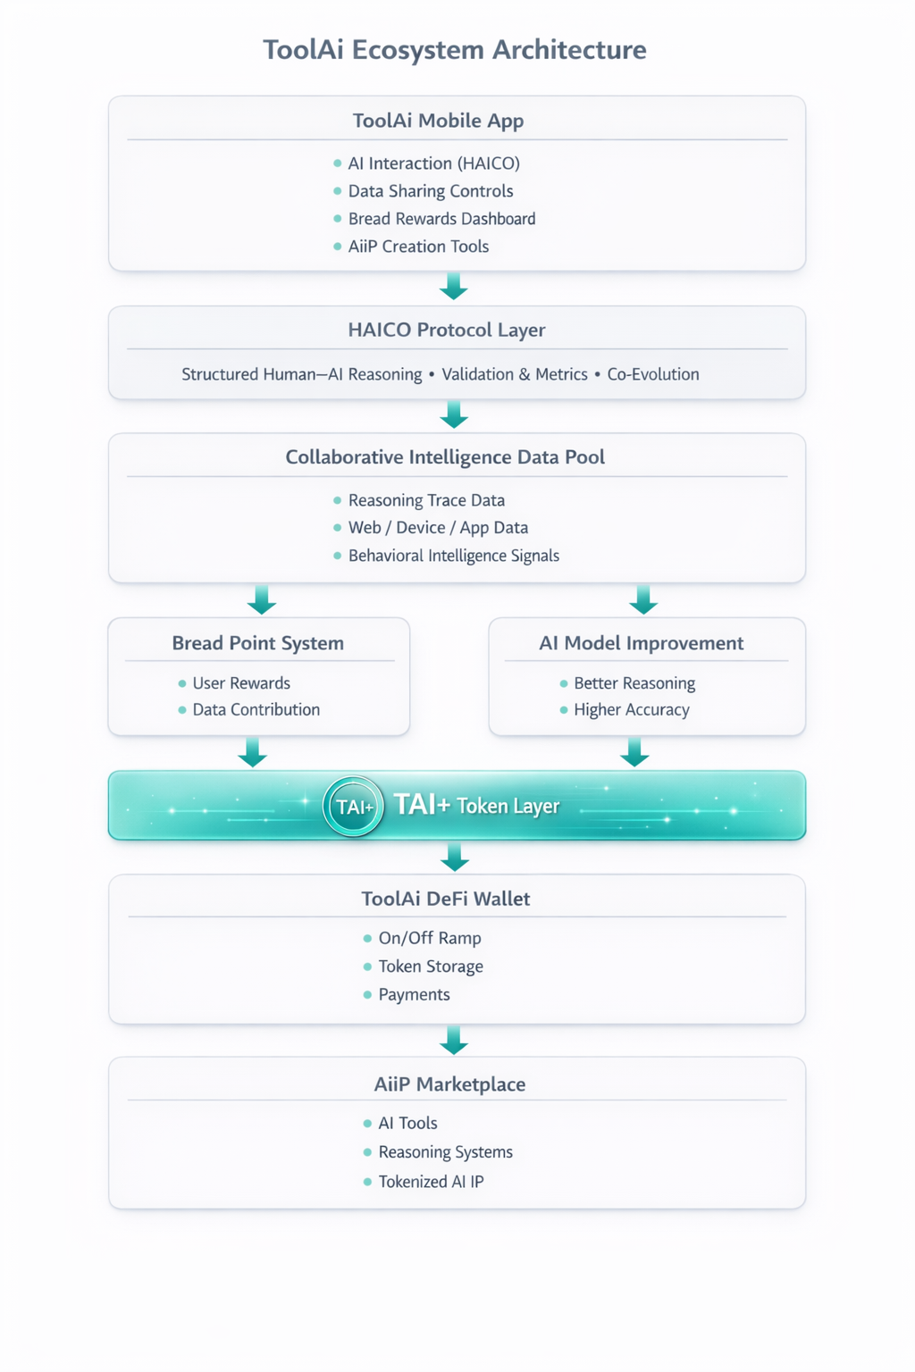
• improve reasoning quality
• reduce hallucination rates
• generate high-quality reasoning trace datasets

14. The ToolAi Flywheel

The ToolAi ecosystem creates a self-reinforcing intelligence network.

Users interact with AI
↓
Structured reasoning workflows
↓
Reasoning trace data generated
↓
AI systems improve
↓
Better collaborative intelligence
↓
More AiiPs created
↓
Marketplace activity increases
↓
Ecosystem value grows
↓
More users join

This feedback loop creates network effects for collaborative intelligence.

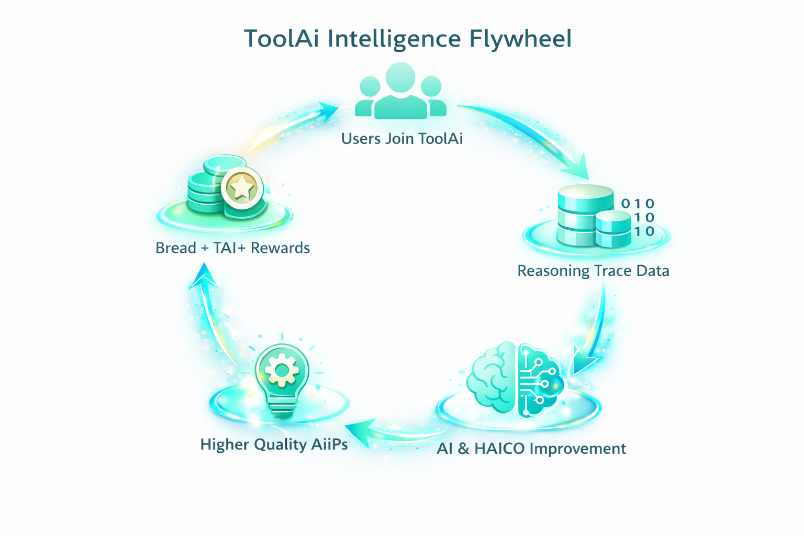




15. HAICO: Human–AI Collaborative Optimization Protocol

The HAICO protocol introduces a structured framework for coordinating reasoning interactions between human participants and artificial intelligence systems.

The protocol defines mechanisms for:

• structured reasoning workflows
• validation architectures
• reasoning trace capture
• collaborative intelligence measurement
• human–AI co-evolution learning

Through these mechanisms, HAICO enables the creation of collaborative intelligence networks where humans and artificial intelligence systems work together to produce reliable reasoning outputs.

Protocol Layer for AI Collaboration

In the same way that HTTP standardized communication between web browsers and servers, HAICO introduces a structured interaction model for collaborative reasoning.

Human Participant
│
▼
Structured Reasoning Input
│
▼
AI Reasoning Systems
│
▼
Validation Protocols
│
▼
Collaborative Intelligence Metrics
│
▼
Reasoning Trace Infrastructure
│
▼
Continuous Human–AI Co-Evolution

This protocol layer enables interoperability between different AI systems and collaborative intelligence platforms.

Enabling a Collaborative Intelligence Ecosystem

By establishing a standardized protocol for human–AI collaboration, HAICO enables the development of new categories of applications including:

• collaborative research platforms
• AI-assisted engineering design systems
• decision-support intelligence networks
• educational reasoning platforms
• distributed AI agent ecosystems

These systems may operate across different computing environments including:

• mobile devices
• enterprise platforms
• cloud infrastructure
• decentralized networks
• embodied AI systems and robotics

Open Innovation Around the Protocol

Just as the internet enabled millions of applications built on open protocols, the HAICO architecture enables an ecosystem of collaborative intelligence systems built around structured reasoning interaction.

Within this ecosystem, developers may build:

• specialized AI reasoning agents
• collaborative intelligence analytics tools
• domain-specific reasoning validation systems
• AI intellectual property assets (AiiPs)

The ToolAi platform provides the first implementation of this protocol through its mobile application, collaborative intelligence analytics infrastructure, and AiiP marketplace.

The Foundation for Collaborative Intelligence Networks

As artificial intelligence systems become increasingly integrated into everyday decision-making processes, the ability to coordinate reasoning collaboration between humans and AI will become essential.

HAICO provides the foundation for this emerging infrastructure layer.

By combining structured reasoning protocols, collaborative intelligence measurement, and decentralized economic incentives, HAICO enables a future in which humans and artificial intelligence systems co-evolve within shared intelligence networks.

16. The Future of Collaborative Intelligence

ToolAi aims to establish the foundational infrastructure for collaborative intelligence networks.

By combining structured reasoning protocols, user-owned data economies, decentralized financial systems, and open AI intellectual property markets, ToolAi enables humans and artificial intelligence systems to co-evolve.

The result is a new form of intelligence infrastructure — one where humans and machines collaborate to produce reliable reasoning and measurable knowledge.


© 2026 ToolAi Labs
ToolAi and HAICO are technologies developed by RocketBuffalo Inc.

